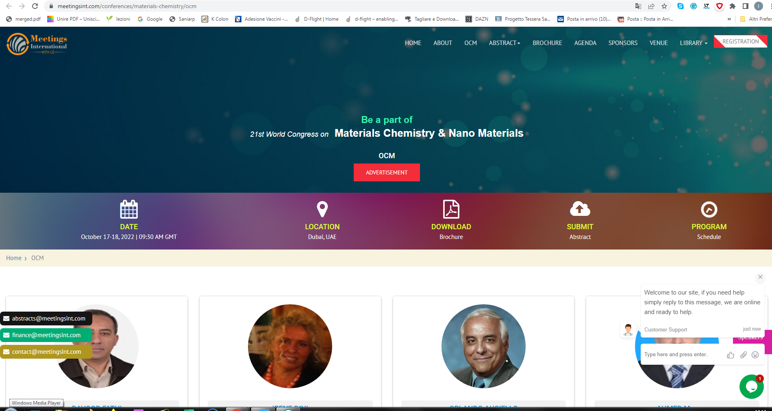
https://www.meetingsint.com/conferences/materials-chemistry/ocm

