CATEGORIA di APPARTENENZA: Salute
ABSTRACT: Exploring cellular uptake, accumulation and mechanism of action of an anticancer Ru(III) complex loaded into a nucleolipidic-based nanosystem in preclinical models of human breast cancer
M. Piccolo^{I}, M.G. Ferraro^{I}, C. Tammaro^{I}, F. Raucci^{I}, F. Maione^{I}, M. Trifuoggi^{II}, D. Montesarchio^{II}, R. Santamaria^{I}, C. Irace^{I}.
^{I}Department of Pharmacy, School of Medicine, University of Naples “Federico II”, Naples, Italy; ^{II}Department of Chemical Sciences, University of Naples “Federico II”, Naples, Italy.
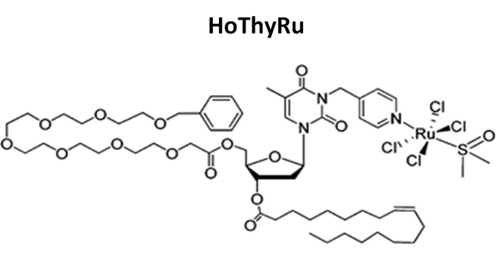
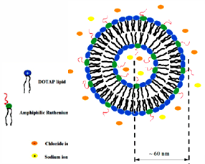
Breast cancer is the second most common cancer in the world after lung cancer, the fifth most common cause of death from cancer, and the leading cause of cancer death in women. According to the World Health Organization, its incidence is constantly increasing so that the development of new effective anticancer drugs with specific mechanisms of action is considered a priority by the scientific community to defeat specific types of cancer, to limit toxic side effects as well as chemoresistance development. The scientific literature shows important advances in the therapeutic field, but concurrently new challenges and debates, i.e. tumour heterogeneity and biomarkers validation for the choice of the best therapy. Moreover, in the specific case of breast cancer, another concrete obstacle to clinical success is often represented by the onset of resistance phenomena to chemotherapeutic agents. In recent years, in the field of metal-based anticancer drugs, numerous ruthenium complexes, both inorganic and organic, have been proposed and tested as alternative drugs to cisplatin and congeners, as they have a strong antiproliferative activity in addition to a lower toxicity profile. Indeed, many ruthenium (III) complexes act as prodrugs, generating active cytotoxic species (Ru II) in situ within specific tumour microenvironment. In this context, our current studies have demonstrated the efficacy of a low molecular weight ruthenium (III) complex (AziRu) incorporated into a cationic nanosystem (named HoThyRu/DOTAP), proved to be hitherto one of the most effective within a suite of nucleolipidic formulations we have developed for the in vivo transport of anticancer ruthenium (III) based drugs¹⁻². Preclinical studies in vitro for the evaluation of cellular response on a selected panel of human breast cancer cells (BCC) - including endocrine-reactive adenocarcinoma cells (ER, MCF-7 line) and triple negative breast adenocarcinoma cells (TNBC, line MDA-MB-231) - have shown that our nanosystems are able to significantly inhibit cell proliferation, through the activation of different cell death pathways, i.e. apoptosis and autophagy³. Hence, based on very motivating results on BCC, in order to investigate animal biological responses to systemic administration of HoThyRu/DOTAP nanosystem, along with its effects on the progression of breast cancer in vivo, we have performed an antitumour study in vivo using athymic nude mice bearing human BCC xenograft. In depth analysis of tumour growth shows that HoThyRu/DOTAP significantly inhibits breast cancer cell proliferation in mice, without any sign of toxicity in treated animal group⁴. Molecular biology experiments have been also performed ex vivo to deepen cellular responses and/or resistance to treatments, as well as to support in vivo the activation of specific pathways of cell death. Ad hoc selected fluorescent molecular probes and inductively coupled plasma mass spectrometry (ICP-MS) analysis have allowed to study cellular "trafficking" as well as ruthenium tissue accumulation after nanosystem treatment in vitro and in vivo. Furthermore, the oncogenic and tumour suppressor role of regulatory proteins has been investigated by immunochemical techniques, proving apoptosis and autophagy involvement behind the antiproliferative action of the HoThyRu/DOTAP nanosystem. Potential agents able to trigger multiple biological responses are attracting more and more interest in the field of promising therapeutic strategies to address chemoresistance and tumour spread, especially if coupled to nanoparticles utilization as the means of targeted delivery while avoiding or reducing undesired side-effects. Following this line, our preclinical investigations suggest that an original strategy based on suitable formulations of novel multi-target Ru-based complexes could open new opportunities for breast cancer treatment, including the highly aggressive triple-negative subtype.

¹Vitiello et al., J. Mater. Chem. B. 3: 3011-3023, 2015. ²Riccardi et al., EurJOC. 7: 1099-1119, 2017. ³Irace et al., SREP. 7:45236, 2017. ⁴Piccolo et al., SREP. 9(1):7006, 2019.

