ADDITIONS, INTEGRATIONS, CORRECTIONS AND SUPPLEMENTS
TO THE BIBLIOGRAPHY OF ARNOLD JOSEPH TOYNBEE*

by Teodoro Tagliaferri (University of Naples Federico II)

No. 310
(September 17th, 2023)

Additions to Part II, Works about Arnold J. Toynbee
Biographical Material
Portraits and Images

1950

310) Toynbee at Stanford in 1950, in «The Stanford Daily», Monday, October 23, 1950, p. 4. Photograph illustrating nos. 307, 309.

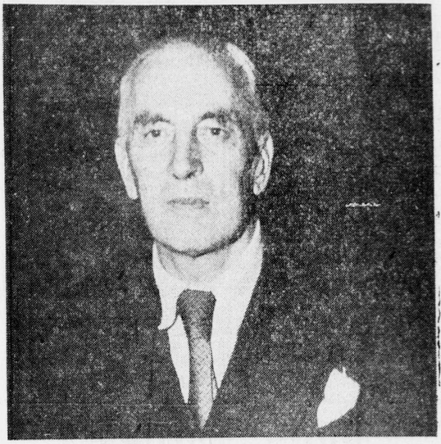

* A Bibliography of Arnold J. Toynbee, compiled by S. Fiona Morton, with a Foreword by Veronica M. Toynbee, Oxford, Oxford University Press, 1980.

