A GREEN ROUTE TO TRANSITION METAL-BASED NANOPARTICLES VIA ALUMINIUM CEMENTATION FOR OER ELECTROCATALYSIS

Domenico Lentini¹⁻², Francesko Malaj²⁻³, Alessandro Tampucci², Carlo Santoro³, Enrico Berretti⁴, Stiven Forti⁵, Antonio Rossi⁵, Oreste Tarallo¹, Francesco Ruffo¹
¹ Department of Chemical Sciences, University of Naples Federico II, Italy
² Ne.m.e.sys. s.r.l., Italy
³ Department of Materials Science, University of Milano-Bicocca, Italy
⁴ Istituto di Chimica Dei Composti OrganoMetallici, Consiglio Nazionale Delle Ricerche, Italy
⁵ Center for Nanotechnology Innovation, Istituto Italiano di Tecnologia, Italy
domenico.lentini@unina.it

Anion Exchange Membrane Water Electrolyzers (AEMWEs) offer a promising route for sustainable hydrogen production^{[1]}. To support their widespread deployment, there is a pressing need for efficient, scalable, and environmentally friendly synthesis of cost-effective electrocatalysts^{[2]}. Here, FeCo₃/FeCoO_{x} and Ni₁₋ₓCoₓ/NiCoO_{x} nanoparticles were synthesized via a two-step aqueous synthesis based on aluminium powder cementation, followed by its alkaline removal (Figure 1). This approach integrates principles of green chemistry, including the use of benign solvents, minimal by-products, and low-cost raw materials under mild conditions.
Comprehensive structural and surface characterization was conducted using HRTEM, HAADF-STEM, XPS, XRD, XRF, and SEM. Electrochemical performance was evaluated by LSV, EIS and tests in a 50 cm² pilot-scale AEMWE cell. As OER electrocatalysts, FeCo₃/FeCoO_{x} and Ni₁₋ₓCoₓ/NiCoO_{x} achieved overpotentials of 288 mV and 296 mV at 10 mA cm⁻², and in AEMWE reached 2.10 V and 2.24 V at 1 A cm⁻² (50 °C), respectively. Both outperformed commercial RuO₂ benchmark in all electrochemical experiments. Stability tests over 100 h in AEMWE cell showed minimal degradation, with Ni₁₋ₓCoₓ/NiCoO_{x} maintaining performance and FeCo₃/FeCoO_{x} exhibiting only 396 µV h⁻¹ degradation.

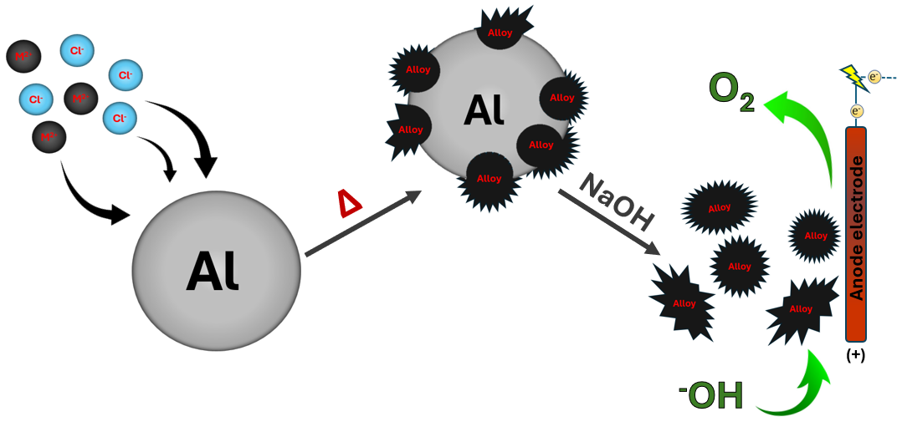
Figure 1: Process diagram

[1] I.Vincent and D.Bessarabov, Renew. Sustain. Energy Rev., 2018, vol. 81, pp. 1690–1704
[2] A. Vazhayil, L. Vazhayal, J. Thomas, S. Ashok C, and N. Thomas, Appl. Surf. Sci. Adv., 2021 vol. 6, p. 100184.

