Effect of pH adjustment on wetting mitigation in Textile Wastewater Treatment by Membrane Distillation

Mariana E. Rodrigues^{1,2}, Andreia S. F. Farinha^{1,2}, Geert-Jan Witkamp^{1,2},
Johannes Vrouwenvelder^{1,2,3}, Luca Fortunato*⁴

¹ Biological & Environmental Science & Engineering Division (BESE) King Abdullah University of Science and Technology (KAUST), Thuwal, 23955-6900, Saudi Arabia
² Environmental Science & Engineering Program (EnSE), King Abdullah University of Science and Technology (KAUST), Thuwal 23955-6900, Saudi Arabia
³Department of Biotechnology, Faculty of Applied Sciences, Delft University of Technology, Van der Maasweg 9, 2629 HZ Delft, The Netherlands
⁴Department of Civil, Building and Environmental Engineering, University of Napoli Federico II, Via Claudio 21, 80125, Napoli, Italy

Abstract
The textile industry has long been associated with significant environmental challenges due to the generation of recalcitrant wastewater, containing complex chemical mixture that pose severe threats to ecosystems and human health. This study focuses on the role of pH adjustment in improving the pretreatment process for direct contact membrane distillation (DCMD) applied to real textile wastewater. By implementing a pH adjustment step (pH 6.14, 7.40, and 9.06) prior to sedimentation and filtration, the pretreatment process was significantly enhanced, reducing wetting, and improving permeate quality. GC-MS analysis identified specific organic molecules causing wetting, including volatile organic acids and alcohol derivatives, revealing that the rejection mechanism is primarily driven by the relationship between the wastewater pH and the pKa of these compounds. Adjusting the pH above the pKa converts these acidic contaminants into ionic, non-volatile forms, effectively preventing their passage into the permeate. This study highlights the importance of pH optimization in advancing DCMD as a sustainable solution for textile wastewater treatment. The proposed approach aligns with circular economy principles, enabling water reuse in textile processes, reducing freshwater consumption, and minimizing environmental discharge.

Keywords: Dye wastewater; Zero Liquid Discharge (ZLD); Industrial water reuse; membrane wetting mitigation; Volatile Organic Compounds (VOCs);

* Corresponding author. E-mail: luca.fortunato@unina.it

1. Introduction

While integral to economic growth, the textile industry has long been associated with significant environmental challenges due to the generation of recalcitrant and toxic wastewater. The effluents from textile processing contain an intricate mixture of pollutants such as dyes, salts, and other contaminants, posing severe threats to ecosystems and human health. Moreover, the dyes used can be mutagenic and carcinogenic in addition to exhibiting complex structures, high molecular weight, and low biodegradability, aggravating the need for a proper treatment to dispose of these streams [1]. Conventional wastewater treatment methods often struggle to effectively address this diverse composition. Therefore, the search for innovative wastewater treatment technologies has intensified in light of the increasing emphasis on environmental responsibility. Currently, membrane technologies are widely recognized as sustainable alternatives for textile wastewater treatment, as demonstrated by numerous studies, producing high-quality effluent suitable for water reuse with compact and efficient operation [2]. Membrane Distillation (MD) offers a unique value proposition for textile wastewater by theoretically rejecting all non-volatile components, tolerating high salinity independent of osmotic pressure [3] and uniquely enabling utilization of waste heat inherently generated during dyeing processes (60–90°C) [4], thereby substantially reducing energy costs compared to pressure-driven membranes. Among membrane separation techniques, MD stands out due to its capacity to harness existing industrial waste heat, thereby enhancing energy efficiency. Techno-economic analyses demonstrate MD treatment costs of $1.17–3.6/m³ with waste heat integration [5], [6], [7] , with payback periods under 2 years for textile ZLD systems [8]. MD operates as a separation method that relies on vapor passing through a hydrophobic microporous membrane, driven by diffusion and convection [9]. This technique offers significant advantages, including operations at lower temperatures and the ability to treat hyper-saline wastewater [10]. Moreover, MD aims towards Zero Liquid Discharge (ZLD) technology, achieving high water recovery rates[7].

Up to this point, different configurations have undergone testing; however, this study emphasizes direct contact membrane distillation (DCMD). DCMD involves the direct interaction of feed and permeate solutions with the membrane surface, offering a more straightforward design and yielding higher flux rates [11]. This system's temperature difference between feed and permeate streams establishes a transmembrane vapor pressure gradient that drives mass transfer. Hence, only vapor molecules can pass through the hydrophobic membrane from warm to cool, setting them apart from other components such as dyes, salts, and non-volatile organic compounds [12], [13]. Currently, a few tools are available to properly monitor the process performances. One of them is Optical Coherence Tomography (OCT) a non-destructive technique called which enables real-time in-situ monitoring of the DCMD operation in real-time [14]. Some authors [14], [15], [16] observed the advance of fouling in MD membranes under continuous operation, while other recent studies, employed OCT to monitor wetting [16], [17], [18], [19].

Despite the numerous advantages, there are drawbacks to DCMD performance that translate to increased process costs and reduced permeate quality. The primary challenges faced by this technology are fouling and wetting. Fouling can reduce productivity by potentially leading to decreased flux rates, and a decline in membrane hydrophobicity during extended operation periods, potentially leading to wetting problems [7]. Conversely, wetting indicates a failure in the rejection mechanism, hampering the quality of the permeate. Membrane wetting can be defined as the passage of liquid through the membrane pores, as opposed to vapor [20]. According to Gryta et al. [21], there are 4 degrees of wetting: non-wetting, surface-wetting, partial-wetting, and full-wetting. The first two maintain a separation between feed and permeate. However, in partial wetting and especially in complete wetting, the permeate quality will be compromised (in distinct levels) due to feed leakage, disrupting the entire treatment and causing the membrane to lose hydrophobicity. However, there is some controversy in the available literature on why this phenomenon happens. By definition, only volatiles can pass through the MD membrane; therefore, in the case of a high concentration of Volatile Organic Substances (VOCs) in the feed, they can easily be transferred to the permeate, the rate depending on the volatility of these components [22]. Additionally, Wang et al. [23] highlighted that surface active agents, surfactants, low-surface tension, and water-miscible liquids can cause wetting. These contaminants reduce surface tension, leading to lower liquid entry pressure (LEP) and feed passes into the membrane pores. Also, the amphiphilic nature of the surfactants can lead the passage of contaminants through the pores by attaching hydrophobic tails to the membrane surface and leaving the hydrophilic head exposed to other substances. Moreover, other studies have highlighted that the rise conductivity can also be an inherent characteristic of the MD process [24]. This phenomenon was attributed to the partial wetting of the membrane pores, which allows saline feed to infiltrate the membrane structure, leading to increased salt passage into the permeate stream. Some methods of wetting detection have been investigated, such as contact angle and LEP measurements, which are wettability indicators, pointing out changes in membrane hydrophobicity, and also the measurement of the increase in permeate conductivity, the conventional technique, allowing real-time detection of wetting [25].
In the context of textile wastewater treatment by DCMD, wetting is a major concern due to the presence of surfactants and other compounds that increase the complexity of these effluents [26]. This phenomenon is often triggered by Volatile Organic Compounds (VOCs) and surface-active agents like surfactants, which reduce the LEP [3], [11], [14]. A significant knowledge gap remains in the current literature, as most studies showcasing high rejection rates utilize synthetic wastewater and experiments under 24 hours [9], [27], [28], [29], [30], which fail to capture the complex, long-term interactions occurring in industrial settings. Furthermore, research often focuses on membrane development or flux decline while overlooking the specific molecular composition of the permeate during wetting and the chemical mechanisms and strategies required to mitigate it. This study addresses these gaps by employing real textile wastewater and utilizing GC-MS analysis to identify the specific organic molecules, that compromise permeate quality. The primary novelty of this work lies in the application of a pKa-volatility mechanism to control these contaminants. We demonstrate that by adjusting the feed pH above the pKa of these identified acids, they are converted into ionic, non-volatile forms, physically preventing their vaporization and subsequent passage through the membrane.

2. Materials and methods

2.1 Materials
The experiments were conducted with a commercially available flat sheet polytetrafluoroethylene (PTFE) membrane, which was supplied by Aquastill. This membrane was selected due to its wide commercial availability, permeability, porosity, and hydrophobic properties [28]. Methyl Orange (MO) (C₁₄H₁₄N₃NaO₃S, molecular weight of 327.34 g/mol, 00/00/0000 00:00:00a pKa of 3.4), with a dye content of 85%, was sourced from Sigma-Aldrich (Lot MKCD5974. Sodium Hydroxide (NaOH), obtained from Sigma-Aldrich (Lot SLBT3085), was used to change the pH of the solutions. Methyl Tert-Butyl Ether (MTBE, Fischer Scientific, Lot 096062) of Sodium chloride (NaCl, VWR Chemicals BDH) was used in the liquid-liquid extraction of organic molecules. All the chemicals used in this work were used without further purification. The wastewater sample was obtained from a textile facility located in Italy. The effluent was sampled from the equalization tank and stored at a temperature of 4 °C in a refrigerator to conserve its properties. The full physicochemical parameters of the wastewater used for this study are summarized in Table S1. To better evaluate color removal efficiency, methyl orange (MO, dye content 85%, Sigma-Aldrich, Lot MKCD5974) was spiked into the wastewater at a concentration of 10 mg/L.

2.2 Methods

2.2.1 DCMD experiments
The DCMD experiments were conducted using a laboratory-scale batch setup, as illustrated in Figure 1. This system comprises a custom DCMD membrane cell with an effective area of 33 cm², allowing for real-time monitoring with OCT. It included a feed tank containing textile wastewater and a permeate tank containing 0.8 L of MiliQ water. Two gear pumps (EW-07002-25, Cole-Parmer, USA) circulated the streams in a counter-current mode. Precise temperature control was maintained using heat exchangers (CORIO CD-600F Refrigerated/heating circulator, Julabo, Germany), with temperature sensors integrated into conductivity meters (TetraCon 325, Xylem Analytics, Germany) for continuous monitoring. Conductivity meters were set in the inlet and in the outlet of the feed and permeate flow cells, enabling tracking of conductivity throughout the experience. Cross-flow velocity and outlet temperature were measured using digital cross-flow meters near the flow cell.
The experimental conditions were as follows: the feed temperature was maintained at 50 °C, with a feed flow rate of 25 L/h and a cross-flow velocity of 0.21 m/s. The permeate temperature was set at 20 °C, with a flow rate of 16 L/h and a cross-flow velocity of 0.13 m/s. In the membrane cell's permeate chamber, three feed spacers were positioned beneath a permeate spacer to facilitate flux and prevent membrane deformation. Mass changes in the permeate were continuously recorded at one-minute intervals using a Sartorius electronic balance (PRACTUM 6101-1S). All instruments were connected to a computer and controlled using LabVIEW software.
The permeate flux J (L/m²•h, LMH) was calculated using Equation (1):
$J=\frac{△W}{△t⋅A}$ (1)
Where △W represents the change in permeate volume (L), △t is the permeate collection time (h), and A denotes the effective area of the membrane (m²).
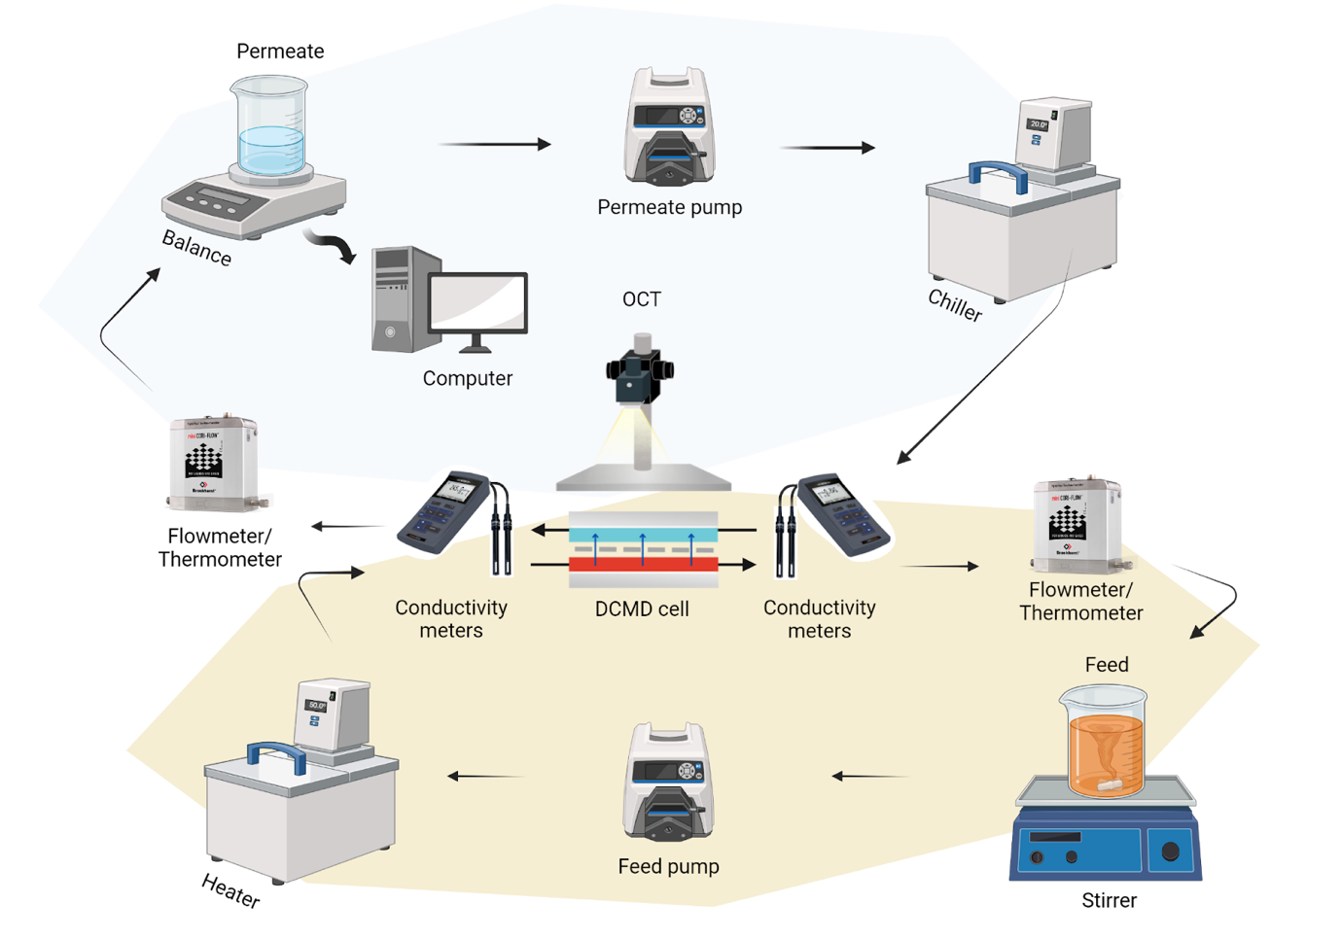
Figure 1: Direct Contact Membrane Distillation (DCMD) experimental setup used in the work.

2.2.2 Pretreatments
In this work, the impact of pretreatment on textile wastewater was evaluated under four different conditions. In all experiments, Methylene Orange (MO) was added at a concentration of 10 mg/L to assess dye removal efficiency. For the first pretreatment, 1300 mL of wastewater was allowed to sediment for 2 days, in a 2L glass beaker, and the supernatant was collected. For the remaining conditions, the pH of wastewater was adjusted prior to sedimentation using sodium hydroxide to achieve pH values of 6.14, 7.40, and 9.06. After 24 hours of sedimentation, the supernatant was collected. In all cases, the collected supernatants were subsequently filtered using a Büchner funnel and an 11 µm filter (Whatman No. 1, 1001-055) to remove suspended solids.

2.2.3 OCT
Optical coherence tomography (OCT) imaging was conducted using the GANYMEDE-II-SP2 system (Thorlabs GmbH, Germany) to monitor in real-time the cross section of the membrane surface. The OCT setup was equipped with the LSM03-BB objective lens (Thorlabs GmbH, Germany). For the acquisition of 2D OCT datasets, A-scan averaging of 3 was employed, and scans were performed every 15 minutes at a fixed location (center of the cell) to monitor fouling progression during operation. These 2D OCT scans exhibited a resolution of 3319 × 1024 pixels, corresponding to dimensions of 6.64 mm × 2.20 mm (width × depth). Post-processing of the original scans involved cropping and adjusting brightness and contrast, which was performed using ImageJ (Fiji software).

2.2.4 Feed and permeate characterization
The chemicals present in raw wastewater and permeate samples were extracted using liquid-liquid extraction with MTBE (ratio of 1:3 of MTBE: sample). To facilitate and enhance phase separation, 1 g of sodium chloride was added to the mixture. The presence of volatile organic chemicals in the extractants was verified in an Agilent GC7890A gas chromatography (GC) coupled with an MS5975c mass spectrometry (MS). A DB-WAX column (J&W Scientific, USA) with a film thickness of 0.25 μm (30 m × 0.25 mm) was utilized to separate the sample. The GC analysis was carried out in spitless mode with helium as the carrier gas at a linear gas velocity of 36.445 cm/s, inlet temperature of 250 °C, and an injection volume of 1 μl. The oven temperature was initially set to 50 °C for 1 min, followed by a heating rate of 10 °C/min until it reached 240 °C and then maintained at 240 °C for 14 min. The MS Quad temperature and the MS source were set to 150 °C and 230 °C, respectively. The scan range of the mass spectrometer was of m/z 35-500. Compound identification was performed using the NIST 20 (2020) mass spectral library (with correspondence higher than >80%). The zeta potential of suspended particles in the pretreated feed solutions was measured by electrophoretic light scattering (ELS) using a Litesizer™ DLS 701 (Anton Paar, Austria). Measurements were performed directly on the pretreated feeds used for this study, without dilution. Analyses were conducted in Univette sample cells at a target temperature of 25 °C. For each condition, three measurements were recorded (n = 3). Zeta potential values were calculated by the instrument software using the Smoluchowski approximation, with default water properties applied for viscosity and dielectric constant.
Feed and permeate metal composition analysis was conducted in an ICP-OES (Inductively Coupled Plasma Optical Emission Spectroscopy) spectrometer (Agilent Technologies, ICP-OES 5110). Previous to analysis, the samples were digested using an UltraWAVE system (Milestone); in this procedure, 5ml of sample was mixed with 1 ml of 70% Nitric acid (HNO₃), the temperature was raised to 250°C within 20 min and held at 250°C for 15 min. Turbidity was measured using a turbidity meter (Micro 100 Turbidimeter, HF scientific, USA) and expressed in nephelometric turbidity units (NTU). The pH of the samples was measured using a Fisherbrand™ Accumet™ AB150 pH Benchtop Meter (Thermo Fisher Scientific, USA). Chemical Oxygen Demand (COD) was determined using Hatch kits (TNT 822, USA). For Total Organic Carbon (TOC), feed and permeate samples were diluted and filtered through a 0.45 μm syringe filter before analysis with the Total Organic Carbon Analyzer (TOC-LCSH, Shimadzu).
The absorbance spectra of the wastewater samples (feed and permeate) were evaluated by UV–vis spectrophotometer (UV-1900i, SHIMADZU), with a 1 cm path length quartz cell. The spectra were recorded from 190 to 1100 nm. The color removal efficiency was calculated using the following formula:
$Color removal (\%)=\frac{(A1-A2)}{A1}× 100$ (2)
Where A1 is the absorbance of the untreated wastewater sample with added MO, and A2 is the absorbance of the permeate at 275 nm.
Feed recovery efficiency was calculated by dividing the volume of the collected permeate (Vp) by the volume of the treated feed solution (Vf), as in the following expression:
$Feed recovery\left(\%\right)= \frac{Vp}{Vf}× 100$ (3)
Percentual rejection rates of the membranes, for feed and permeate conductivities at the same time, were calculated using Equation (4):
$Rejection (\%)=\frac{(Cf-Cp)}{Cf}× 100$ (4)
Where Cf is the conductivity of the feed (µS/cm), and Cp is the conductivity of the permeate (µS/cm).
Conductivity over volume rates were calculated at the same produced volume across all experiments, using equation (5):
$Conductivity over volume (µS/cm*L⁻¹)=\frac{(Fcp-Icp)}{Vp}$ (5)
This calculation represents the change in conductivity per liter of processed water, where Fcp is the final conductivity of the permeate (measured at the target volume), Icp is the initial conductivity of the permeate, and Vp is the volume of permeate produced.
2.2.5 Membrane characterization
For tracing functional groups present on top of the membrane, Attenuated Total Reflectance - Fourier transform infrared (ATR-FTIR) spectra of the samples were recorded using a Thermo Scientific Nicolet iS50R FTIR spectrometer. The spectra were obtained at a resolution of 4 cm⁻¹ and an average of 16 sample scans. The surface zeta potential of the PTFE membrane was determined using a SurPASS 3 electrokinetic analyzer (Anton Paar, Austria) employing the streaming potential method. Measurements were conducted in a 0.01 M KCl electrolyte solution, with the pH adjusted stepwise from 3 to 9 (ΔpH = 1) using HCl and KOH. All experiments were performed at room temperature (22 °C). For each pH value, three measurement cycles were recorded, with an upper pressure limit of 450 mbar. The membrane surface was rinsed with electrolyte solution for five cycles between measurements to ensure stabilization. Zeta potential values were calculated using the Helmholtz-Smoluchowski equation.

3. Results and Discussion

3.1 Impact of the feed pH on DCMD performance
Due to the high concentration of suspended solids in the feed (~470 mg/L) we performed sedimentation and filtration as first stage of our pretreatment. This two-step pretreatment for textile wastewater is reported in the literature by our group as an effective pretreatment for the removal of suspended solids [31]. This pretreatment of sedimentation followed by filtration (Figure 2a) led to a mostly stable flux (10.5 LMH) for the observation period, without the deposition of significant fouling layer on the membrane (32 µm). However, despite the constant flux, it was possible to observe a steep increase in conductivity during the first hour of operation. In fact, the permeate conductivity achieved 200 µS/cm after 5 hours and increased its value up to 440 µS/cm after 26 hours of operation, suggesting a significant wetting phenomenon (Figure 2e).
To assess the impact of different pH levels before sedimentation and filtration, the pH of the feed solution was adjusted from the initial value of 3.33 to 6.14, 7.40 and 9.06 in separate experiments. The test performed at pH 6.14 (Figure 2b), led to an average flux of 10.41 LMH, reaching a permeate conductivity of 43.22 µS/cm by the end of 26h. At pH 7.40 (Figure 2c), a stable flux with an average of 9.69 LMH, reached 13.81 µS/cm permeate conductivity by the end of 26h. In the third pH condition (pH 9.06) an average flux of 10.24 LMH and 19.5 µS/cm permeate conductivity was achieved by the end of 26h (Figure 2d). Overall, changes in the pH led to a fast sedimentation, suggesting better removal of compounds and consequently an increase of quality of the feed wastewater. Unlike conductivity measurements, which only signal that a failure has occurred, OCT was employed as a complementary monitoring tool to provide real-time, in-situ cross-section of the membrane surface. OCT confirmed that while flux remained comparable across trials, the fouling layer slightly varied across the trials (30 µm at pH 7.40 vs. 50 µm at pH 9.06).
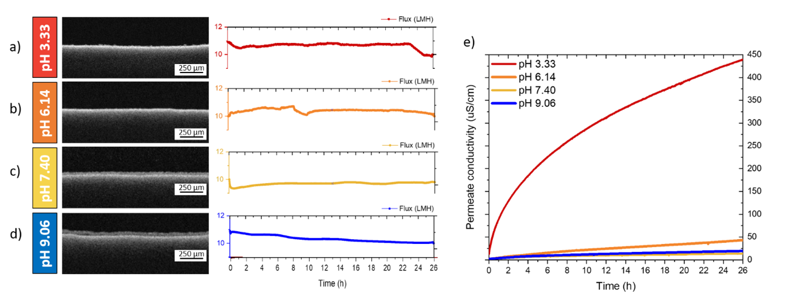Figure 2: Optimization of pretreatment conditions and the impact of pH adjustments on operational parameters. Flux and OCT images from experiments with different pretreatment conditions after 26h: a) Sample at original pH 3.33 with Sed/Fil; b) pH adjusted to 6.14 + Sed/Fil; c) pH adjusted to 7.40 + Sed/Fil; d) pH adjusted to 9.06 + Sed/Fil; (e) Corresponding conductivity values for these experiments.

3.2 Wetting assessment and contaminant rejection
The results demonstrate that while flux may appear stable, permeate quality varies drastically depending on the pH of the feed. The permeate conductivity is considered a conventional wetting assessment technique [20], as it reflects the concentration of salts in solution and consequently the passage of ions to the permeate. Among the pretreatment methods, pH adjustment significantly enhances conductivity reduction. Compared to sedimentation and filtration alone, which yielded a conductivity over volume of 458.65 (µS/cm)*L⁻¹, adjusting the pH to 6.14 reduced conductivity by 89.91%, while adjustments to 7.40 and 9.06 achieved reductions of 96.89% and 95.92%, respectively (Figure 3). Additionally, the calculated percentage rejection, based on the difference between permeate conductivity in the experiments and their feeds, indicates rejection rates exceeding 99% when pH is increased (Figure 3). Total Organic Carbon (TOC) and Chemical Oxygen Demand (COD) and are two important water quality parameters, widely used for assessing the level of organic matter in wastewater and the impact of its discharge will have on the environment. Removal rates reached up to 98% TOC and 97% COD (Figure S1), validating the effectiveness of pH-optimized pretreatment for real textile matrices. This improvement reflects a fundamental shift in how organic contaminants interact with the membrane. These results clearly demonstrated that the DCMD process can provide good rejection rates and that incorporating pH adjustment in pretreatment successfully reduces wetting.
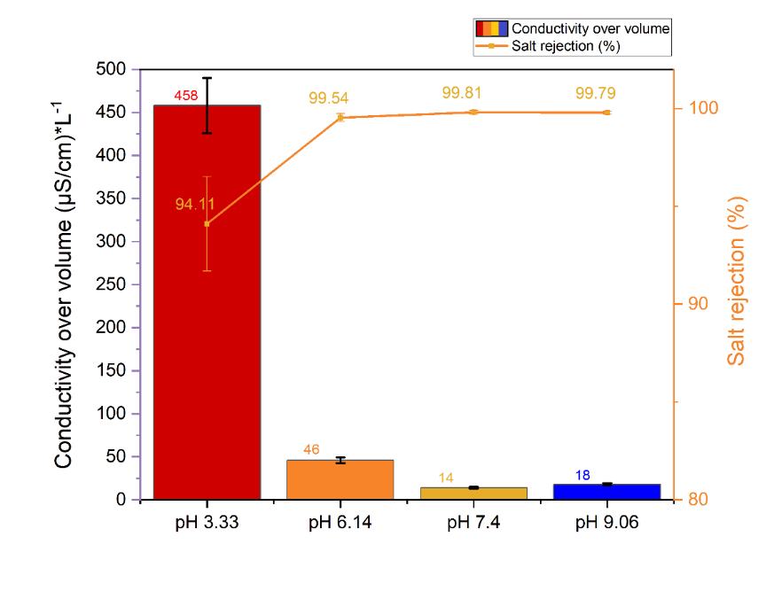
Figure 3: Impact of pretreatment on conductivity over volume of the experiments, which is related with the wetting rate comparison between the experiments and the rejection by the membrane in pH 3.33 (original value), pH6.14, pH7.40, and pH9.06.

3.3 Molecular level investigation and pKa-volatility mechanism
To further understand the wetting phenomena occurring in our experiments we perform a GC-MS analyzed of the obtained permeates. The GC-MS results of permeate obtained from the raw wastewater revealed a complex mixture of chemicals, where the most predominant organic substances detected (>70 % of observed peaks) were selected for further semi-quantitative GC-MS analysis (Figure S2). These included carboxylic acids (acetic acid, formic acid, butanoic acid, n-hexadecanoic acid, propanoic acid), alcohol derivatives (2-ethyl-1-Hexanol, 2-(2-butoxyethoxy)-Ethanol, 2-(2-methoxypropoxy)-1-Propanol, 2-butoxy Ethanol) and aromatic compounds (1-butyl-2-Pyrrolidinone, phenol) (Table S2). The relative abundance of the compounds from each family present in the feed’s samples, allowed to assess the efficiency of the pretreatment.
The chromatograms of permeates obtained in experiments done with pH adjustment (pH 6.14, 7.40, and 9.06) (Figures S4, S5, S6), revealed a reduced number of compounds with a particular decrease on the carboxylic acid composition (Figure 4b), reinforcing the efficiency of pH adjustment as a pretreatment. The improvement in membrane rejection rates can be attributed to the relationship between the pH of the wastewater and the pKa of the compounds present in the feed (Table S2). The pKa of a compound represents the pH at which it exists in equilibrium between its protonated (neutral) and deprotonated (ionic) forms. When the pH of the wastewater is adjusted above the pKa of acidic compounds, these substances predominantly shift to their ionic form. Ionic compounds are less volatile than their neutral counterparts, meaning they are less likely to vaporize and pass through the membrane during the direct contact membrane distillation (DCMD) process [32]. This behavior enhances the membrane's ability to reject these compounds, improving the overall quality of the permeate. Indeed, most of the identified organic acids have pKa below 6, therefore by adjusting the pH above this threshold, those acids are converted predominantly in their ionic form and consequently are less volatile. Further evidence of this phenomenon is provided by the presence of phenol (pKa of 9.89) in all the permeate samples, regardless of the pH. This rejection mechanism explains why the experiment with pH 9.06 presented the best performance, with less compounds passing to the permeate. Notably, 2-butoxy-ethanol, with pKa >14, is detected in all samples. Furthermore, its role as a surfactant likely contributes to its presence in the permeate, highlighting the complexity of the rejection process in MD. In fact, the role of pH adjustment in MD has been previously mentioned by Yan et al. [33], who demonstrated that decreasing the pH of the feed significantly improved ammonia rejection by transforming the volatile ammonia into the nonvolatile form. Hence, it is critical to consider the composition of the wastewater including the chemical properties (such as pKa and volatility) when designing pretreatment strategies for effective membrane distillation operation.
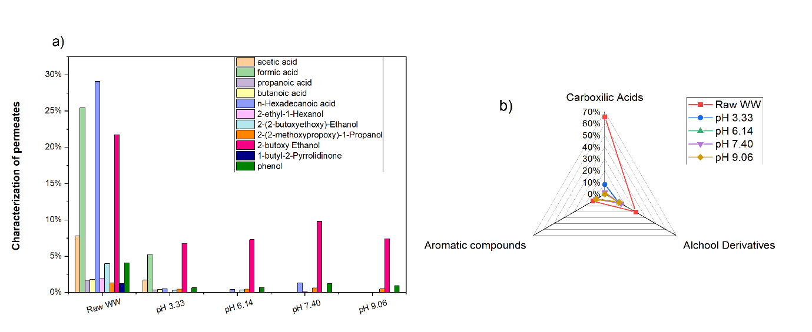

Figure 4: a) Relative abundance (%) of organic compounds identified by GC–MS in the raw wastewater (Raw WW) and in the permeates obtained after different pretreatment conditions. Pretreatments include sedimentation followed by filtration at the natural wastewater pH (pH 3.33), and pH adjustment to 6.14, 7.40, or 9.06 prior to sedimentation and filtration. b) The compounds were categorized into their respective chemical families: carboxylic acids, alcohol derivatives, and aromatic compounds. The diagram summarizes the pretreatment removal efficiency associated with each family detected in the analyzed samples

3.4 Membrane surface characterization
To explore the chemical affinities between membrane surface and solutes in the MD feed, Attenuated Total Reflectance - Fourier transform infrared (ATR-FTIR) analysis was conducted on pristine membranes and after each experiment (Figure 5).
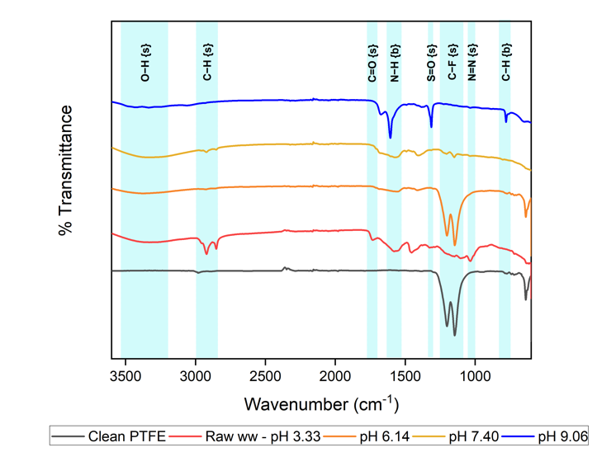
Figure 5: FTIR-ATR spectra from the pristine and fouled membranes. The {s} and {b} designations represent peaks caused by stretching and bending modes, respectively.

ATR-FTIR measurements identified the characteristic bands of PTFE at 1201 and 1146 cm⁻¹, attributed with strong C-F stretching in fluoro compounds of the membrane material. These bands were observed across all samples, with variations in intensity linked to organic fouling on the membrane surface. Organic fouling was further confirmed by the presence of functional groups such as OH stretching band (3330 cm⁻¹), CH stretching peaks (2920), –CH₃ stretching vibrations (2851 cm⁻¹), C=O stretching (1735 cm⁻¹), and N–H bending peaks (1650-1550cm⁻¹).
FTIR analyses allowed to observe the characteristic bands of MO, more pronounced at the sample at pH 9, stretching of –S=O (1310 cm^{–1}) and –N=N− stretching vibration (1033 cm⁻¹) [34], [35]. With the increase of fouling, it is expected to see a decrease of the intensity of peaks associated with the membrane's surface functional groups. Membranes from experiments at pH 9.06 and 7.40 showed slightly higher deposition on the membrane, with reduced intensity of functional group peaks, while the membrane from pH 6.14 closely resembled the pristine membrane, with better preservation of hydrophobicity. These findings are in concordance with the results obtained with OCT (Figure 2). Moreover, the surface charge of both the membrane and the feed particles were evaluated. The PTFE membrane surface became progressively more negatively charged as the pH increased, shifting from –19.39 mV at pH 3 to –51.57 mV at pH 9. Conversely, the suspended particles in the wastewater showed only mildly negative zeta potentials (–5.98 to –15.71 mV) with limited variation, regardless of the pH adjustment. It is worth noting that while the membrane became more negatively charged at higher pH levels, this did not lead to reduced fouling. Furthermore, the passage of Phenol (a neutral volatile) even at the highest pH confirms that electrostatic repulsion is not the primary driver of rejection in this system. Instead, these results support the conclusion that pH adjustment improves performance primarily by modifying feed chemistry and affecting the volatility of weak acids via the pKa mechanism.

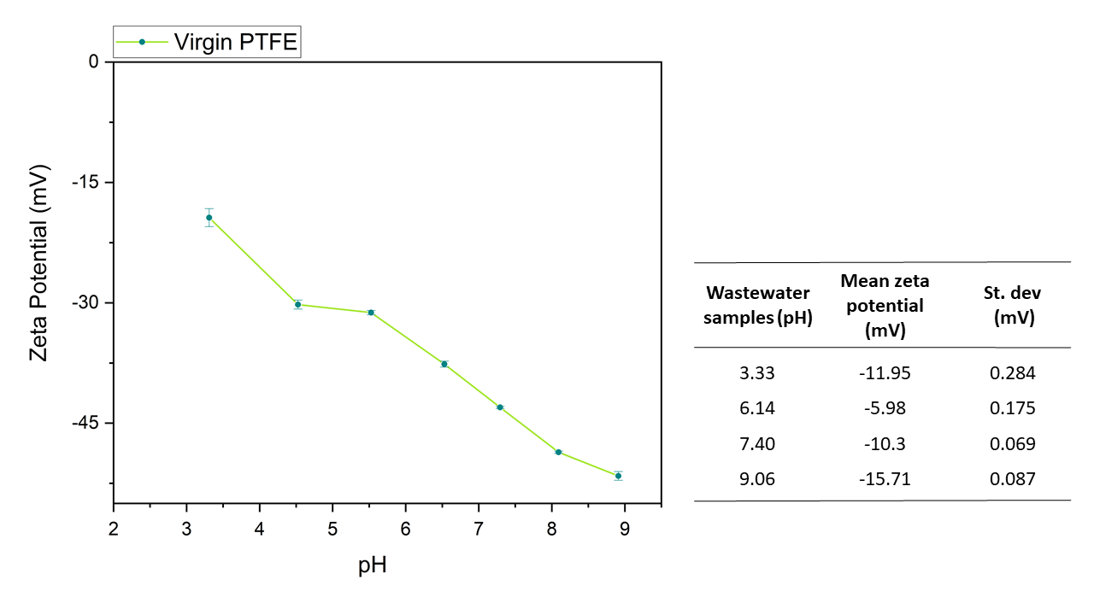
Figure 6: Zeta potential characterization of the virgin PTFE membrane as a function of pH (left) and suspended particles in pretreated feed solutions (right), measured by electrophoretic light scattering (ELS) at pH 3.33, 6.14, 7.40, and 9.06. The PTFE membrane surface exhibits progressively more negative zeta potential with increasing pH, while feed particles exhibit low negative zeta potential values across the investigated pH range.

3.6 Permeate quality and industrial reuse potential
The textile industry faces a pressing need to enhance sustainability by aligning with Sustainable Development Goals (SDGs) 6, 12, and 14, while promoting circular economy principles [36]. This involves creating processes where resources are not only consumed but reused, recycled, and maintained for prolonged use. Some studies have explored the potential of reusing treated wastewater in textile dyeing or other steps of the process while maintaining final product quality [37], [38], [39], [40]. Nevertheless, the majority of these studies exhibit limitations and, in some cases, result in poorer quality of the treated wastewater, along with an inability to remove salts or reduce conductivity as effectively as membrane distillation [39], [40].
To assess the possibility of water reuse of our proposed pretreatment, the permeates were fully characterized in terms of color removal, the turbidity and elements composition. Color removal (Figure S7), was assessed by UV-Vis spectroscopy at 275 nm (table S3). Raw wastewater exhibit a dark brown, turbid appearance. Following sedimentation and filtration, color decreased significantly in the feed, evident to the naked eye as a color change to pale brown. The introduction of the pH adjustment to the pretreatment resulted in total removal of color in the permeate (naked eye inspection) and also a ~99.9% absorbance decreases at 275 nm.
The turbidity of all experiments was under 1 NTU, which is in accordance with the clean water standard regulated by the World Health Organization [41]. In addition, the applied pretreatment showed excellent feed recovery rates (>93%), up to 95% in the best trials (pH 7.40 and 9.06) (Table S4). Another key parameter of water quality is the inorganic composition, the presence of metals out of the regulated concentration can hinder the reuse and discharge of the treated water [42]. Using ICP-OES we inspected that presence and quantities of metals in the raw wastewater and its rejection through DCMC (Table 1). Raw wastewater sample showed ppm levels of aluminum, chromium, iron, phosphor and sulfur. After DCMD, there was a significant decrease in concentration of all the elements. The permeate samples resulting from the three-step protocol (pH change, sedimentation and filtration) showed a decrease of metal content superior to 98%.

Table 1: Elements rejection measured by ICP-OES.
 |  | Rejection (%)
Elements | Pure wastewater Concentration (ppm) | pH 3.33 Sed/Fil Permeate | pH 6.14 Sed/Fil Permeate | pH 7.40 Sed/Fil Permeate | pH 9.06 Sed/Fil Permeate
Al | 34.14 | 99.6% | > 99.9% | > 99.9% | > 99.9%
Cr | 88.04 | 99.8% | > 99.9% | > 99.9% | > 99.9%
Fe | 4.51 | 98.0% | > 99.9% | > 99.9% | > 99.9%
P | 2.73 | 98.5% | 98.9% | > 99.9% | 98.9%
S | 305.5 | 99.8% | 99.9% | 99.9% | 99.9%

The feed recovery, color removal, salt rejection, metal removal, COD, and TOC values obtained in this investigation demonstrate high permeate quality, making it suitable for reuse not only for dyeing and finishing processes but also for other onsite non-potable uses, such as cooling towers or cleaning. Among the tested pretreatment conditions, pH 7.40 yielded the best overall performance, producing neutral effluents suitable for discharge and reuse while effectively mitigating membrane wetting. Importantly, this pH adjustment did not induce significant fouling or flux decline, indicating minimal operational interference. From an economic perspective, maintaining the feed within a near-neutral pH range aligns with regulatory discharge limits and industrial reuse standards, since acid-base neutralization is a core requirement of industrial effluent treatment to protect receiving waters and infrastructure [42], [43], making extensive post-treatment pH correction unnecessary and reducing chemical consumption and operational complexity. The high water recovery rate (95%) achieved in this study directly reduces the use of freshwater and wastewater disposal fees. The permeate quality meets stringent requirements for reuse in textile dyeing and finishing processes [37, 38], enabling closed-loop water management and alignment with circular economy principles. Critically, MD's ability to utilize existing dyeing waste heat (60–90°C) [4], with studies demonstrating that waste heat integration reduces the costs of production of wastewater from €7.6–9.1/m³ to €3.6–4.1/m³ [44]. While surfactant-induced wetting (as evidenced by 2-butoxyethanol detection) remains a challenge requiring additional pretreatment optimization, the pKa-volatility mechanism successfully addressed the dominant wetting pathway (volatile organic acids), demonstrating that MD's known drawbacks can be systematically mitigated through targeted, low-cost interventions implementable within existing treatment processes.
The results presented in this study support the use of DCMD technology as a promising solution for textile wastewater treatment and reuse. It overcomes some limitations of traditional methods such as coagulation, precipitation, and biological processes, which are often costly and yield lower water quality compared to this study [3], [39], [40], [45]. While other advanced methods, such as AOPs and pressure-driven membranes, face challenges like harmful byproducts and high energy demands, DCMD offers high separation efficiency, lower energy consumption, easy maintenance, and environmental benefits.

4. Conclusions
This study demonstrates that integrating pH adjustment prior to sedimentation and filtration provides a strategy for enhancing Direct Contact Membrane Distillation (DCMD) performance in treating recalcitrant textile wastewater. The primary finding is the identification of the pKa-volatility mechanism, where increasing the feed pH above the pKa of identified acidic contaminants, such as acetic, formic, and butanoic acids, converts these molecules from neutral, volatile states into ionic, non-volatile forms, physically preventing their transport through the membrane. This mechanism was definitively validated by the behavior of phenol (pKa 9.89), which remained volatile and permeated the membrane because the feed pH never exceeded its pKa threshold. Despite this success for acidic compounds, the consistent detection of 2-butoxyethanol (pKa > 14) underscores that volatile surfactants remain a significant challenge for membrane distillation, highlighting the ongoing need for targeted removal strategies.
The trial at pH 7.40 was identified as the best operational test, achieving high rejection rates (>99% conductivity and 97% COD) and a water recovery rate of 95% while aligning with industrial reuse standards and regulatory discharge limits. The proposed approach promotes circular economy practices and providing a scalable, sustainable alternative for DCMD-based textile wastewater management.

Acknowledgments
The research reported in this paper was supported by funding from King Abdullah University of Science and Technology (KAUST), Saudi Arabia. L.F. acknowledges support from the European Research Council (ERC) Project AMF (Grant No. 101163880)
References

[1] J. Dasgupta, J. Sikder, S. Chakraborty, S. Curcio, and E. Drioli, “Remediation of textile effluents by membrane based treatment techniques: A state of the art review,” J. Environ. Manage., vol. 147, pp. 55–72, Jan. 2015, doi: 10.1016/j.jenvman.2014.08.008.
[2] B. Keskin, M. E. Ersahin, H. Ozgun, and I. Koyuncu, “Pilot and full-scale applications of membrane processes for textile wastewater treatment: A critical review,” J. Water Process Eng., vol. 42, p. 102172, Aug. 2021, doi: 10.1016/j.jwpe.2021.102172.
[3] H. Ramlow, R. Antonio, F. Machado, C. Marangoni, U. R. João, and D. Ferreira, “Direct contact membrane distillation for textile wastewater treatment: a state of the art review,” 2017, doi: 10.2166/wst.2017.449.
[4] A. K. An, J. Guo, S. Jeong, E. J. Lee, S. A. A. Tabatabai, and T. O. Leiknes, “High flux and antifouling properties of negatively charged membrane for dyeing wastewater treatment by membrane distillation,” Water Res., vol. 103, pp. 362–371, Oct. 2016, doi: 10.1016/j.watres.2016.07.060.
[5] F. Macedonio, “Membrane Distillation Applications,” in Encyclopedia of Membranes, E. Drioli and L. Giorno, Eds., Berlin, Heidelberg: Springer Berlin Heidelberg, 2015, pp. 1–4. doi: 10.1007/978-3-642-40872-4_362-1.
[6] I.- Noor, A. Martin, and O. Dahl, “Techno-economic system analysis of membrane distillation process for treatment of chemical mechanical planarization wastewater in nano-electronics industries,” Sep. Purif. Technol., vol. 248, p. 117013, Oct. 2020, doi: 10.1016/j.seppur.2020.117013.
[7] N. Dow et al., “Demonstration of membrane distillation on textile waste water: assessment of long term performance, membrane cleaning and waste heat integration,” Environ. Sci. Water Res. Technol., vol. 3, no. 3, pp. 433–449, 2017, doi: 10.1039/C6EW00290K.
[8] I. Vergili, Y. Kaya, U. Sen, Z. B. Gönder, and C. Aydiner, “Techno-economic analysis of textile dye bath wastewater treatment by integrated membrane processes under the zero liquid discharge approach,” Resour. Conserv. Recycl., vol. 58, pp. 25–35, Jan. 2012, doi: 10.1016/j.resconrec.2011.10.005.
[9] N. P. Khumalo et al., “Congo red dye removal by direct membrane distillation using PVDF/PTFE membrane,” Sep. Purif. Technol., vol. 211, pp. 578–586, Mar. 2019, doi: 10.1016/J.SEPPUR.2018.10.039.
[10] H. Julian, N. Nurgirisia, G. Qiu, Y.-P. Ting, and I. G. Wenten, “Membrane distillation for wastewater treatment: Current trends, challenges and prospects of dense membrane distillation,” J. Water Process Eng., vol. 46, p. 102615, Apr. 2022, doi: 10.1016/j.jwpe.2022.102615.
[11] L. Eykens, T. Reyns, K. De Sitter, C. Dotremont, L. Pinoy, and B. Van der Bruggen, “How to select a membrane distillation configuration? Process conditions and membrane influence unraveled,” Desalination, vol. 399, pp. 105–115, Dec. 2016, doi: 10.1016/j.desal.2016.08.019.
[12] N. A. S. Muhamad, M. A. H. M. Hanoin, N. M. Mokhtar, and R. Naim, “Insights into Membrane Distillation Application for Textile Wastewater Treatment – A Review,” J. Appl. Membr. Sci. Technol., vol. 25, no. 3, pp. 29–51, Nov. 2021, doi: 10.11113/AMST.V25N3.219.
[13] R. de S. Silva, H. Ramlow, C. D. Á. K. Cavalcanti, R. de C. S. C. Valle, R. A. F. Machado, and C. Marangoni, “Steady state evaluation with different operating times in the direct contact membrane distillation process applied to water recovery from dyeing wastewater,” Sep. Purif. Technol., vol. 230, Jan. 2020, doi: 10.1016/j.seppur.2019.115892.
[14] L. Fortunato, H. Elcik, B. Blankert, N. Ghaffour, and J. Vrouwenvelder, “Textile dye wastewater treatment by direct contact membrane distillation: Membrane performance and detailed fouling analysis,” J. Membr. Sci., vol. 636, Oct. 2021, doi: 10.1016/j.memsci.2021.119552.
[15] H. Elcik, L. Fortunato, J. S. Vrouwenvelder, and N. Ghaffour, “Real-time membrane fouling analysis for the assessment of reclamation potential of textile wastewater processed by membrane distillation,” J. Water Process Eng., vol. 43, p. 102296, Oct. 2021, doi: 10.1016/j.jwpe.2021.102296.
[16] J. Guo, P. W. Wong, B. J. Deka, B. Zhang, S. Jeong, and A. K. An, “Investigation of fouling mechanism in membrane distillation using in-situ optical coherence tomography with green regeneration of fouled membrane,” J. Membr. Sci., vol. 641, p. 119894, Jan. 2022, doi: 10.1016/j.memsci.2021.119894.
[17] A. Bauer, M. Wagner, H. Horn, and F. Saravia, “Operation conditions affecting scale formation in membrane distillation - An in situ scale study based on optical coherence tomography,” J. Membr. Sci., vol. 623, p. 118989, Apr. 2021, doi: 10.1016/j.memsci.2020.118989.
[18] S. Shao et al., “Unraveling the Kinetics and Mechanism of Surfactant-Induced Wetting in Membrane Distillation: An In Situ Observation with Optical Coherence Tomography,” Environ. Sci. Technol., vol. 56, no. 1, pp. 556–563, Jan. 2022, doi: 10.1021/acs.est.1c05090.
[19] D. Shi, T. Gong, W. Qing, X. Li, and S. Shao, “Unique Behaviors and Mechanism of Highly Soluble Salt-Induced Wetting in Membrane Distillation,” Environ. Sci. Technol., vol. 56, no. 20, pp. 14788–14796, Oct. 2022, doi: 10.1021/acs.est.2c03348.
[20] H. Chamani, J. Woloszyn, T. Matsuura, D. Rana, and C. Q. Lan, “Pore wetting in membrane distillation: A comprehensive review,” Prog. Mater. Sci., vol. 122, p. 100843, Oct. 2021, doi: 10.1016/j.pmatsci.2021.100843.
[21] M. Gryta, “Influence of polypropylene membrane surface porosity on the performance of membrane distillation process,” J. Membr. Sci., vol. 287, no. 1, pp. 67–78, Jan. 2007, doi: 10.1016/j.memsci.2006.10.011.
[22] M. Tomaszewska, M. Gryta, and A. W. Morawski, “Mass transfer of HCl and H2O across the hydrophobic membrane during membrane distillation,” J. Membr. Sci., vol. 166, no. 2, pp. 149–157, Mar. 2000, doi: 10.1016/S0376-7388(99)00263-X.
[23] Z. Wang and S. Lin, “Membrane fouling and wetting in membrane distillation and their mitigation by novel membranes with special wettability,” Water Res., vol. 112, pp. 38–47, Apr. 2017, doi: 10.1016/j.watres.2017.01.022.
[24] M. Hardikar et al., “Pore flow and solute rejection in pilot-scale air-gap membrane distillation,” J. Membr. Sci., vol. 676, p. 121544, Jun. 2023, doi: 10.1016/j.memsci.2023.121544.
[25] P. Jacob, S. Laborie, and C. Cabassud, “Visualizing and evaluating wetting in membrane distillation: New methodology and indicators based on Detection of Dissolved Tracer Intrusion (DDTI),” Desalination, vol. 443, pp. 307–322, Oct. 2018, doi: 10.1016/j.desal.2018.06.006.
[26] N. Dow et al., “Demonstration of membrane distillation on textile waste water assessment of long term performance, membrane cleaning and waste heat integration,” Environ. Sci. Water Res. Technol., vol. 3, no. 3, pp. 433–449, May 2017, doi: 10.1039/c6ew00290k.
[27] N. M. Mokhtar, W. J. Lau, A. F. Ismail, W. Youravong, W. Khongnakorn, and K. Lertwittayanon, “Performance evaluation of novel PVDF-Cloisite 15A hollow fiber composite membranes for treatment of effluents containing dyes and salts using membrane distillation,” RSC Adv., vol. 5, no. 48, pp. 38011–38020, 2015, doi: 10.1039/c5ra00182j.
[28] H. Ramlow, R. A. F. Machado, A. C. K. Bierhalz, and C. Marangoni, “Dye synthetic solution treatment by direct contact membrane distillation using commercial membranes,” Environ. Technol. U. K., vol. 41, no. 17, pp. 2253–2265, Jul. 2020, doi: 10.1080/09593330.2018.1561758.
[29] F. Li et al., “Direct contact membrane distillation for the treatment of industrial dyeing wastewater and characteristic pollutants,” Sep. Purif. Technol., vol. 195, pp. 83–91, Apr. 2018, doi: 10.1016/j.seppur.2017.11.058.
[30] M. M. A. Shirazi, S. Bazgir, and F. Meshkani, “A novel dual-layer, gas-assisted electrospun, nanofibrous SAN4-HIPS membrane for industrial textile wastewater treatment by direct contact membrane distillation (DCMD),” J. Water Process Eng., vol. 36, p. 101315, Aug. 2020, doi: 10.1016/j.jwpe.2020.101315.
[31] M. E. Rodrigues, R. Cucciniello, A. Farinha, J. Vrouwenvelder, and L. Fortunato, “Wetting challenges in treatment of raw textile wastewater by membrane distillation: A case study,” Case Stud. Chem. Environ. Eng., vol. 11, p. 101197, Jun. 2025, doi: 10.1016/j.cscee.2025.101197.
[32] A. Khiter, B. Balannec, A. Szymczyk, O. Arous, N. Nasrallah, and P. Loulergue, “Behavior of volatile compounds in membrane distillation: The case of carboxylic acids,” J. Membr. Sci., vol. 612, p. 118453, Oct. 2020, doi: 10.1016/j.memsci.2020.118453.
[33] Z. Yan et al., “Treatment of anaerobic digestion effluent using membrane distillation: Effects of feed acidification on pollutant removal, nutrient concentration and membrane fouling,” Desalination, vol. 449, pp. 6–15, Jan. 2019, doi: 10.1016/j.desal.2018.10.011.
[34] G. K. Parshetti, A. A. Telke, D. C. Kalyani, and S. P. Govindwar, “Decolorization and detoxification of sulfonated azo dye methyl orange by Kocuria rosea MTCC 1532,” J. Hazard. Mater., vol. 176, no. 1, pp. 503–509, Apr. 2010, doi: 10.1016/j.jhazmat.2009.11.058.
[35] M. El Gamal, F. M. Mohamed, M. A. Mekewi, F. S. Hashem, M. R. El-Aassar, and R. E. Khalifa, “Adsorptive removal of methyl orange from aqueous solutions by polyvinylidene fluoride triflouroethylene/carbon nanotube/kaolin nanocomposite: kinetics, isotherm, and thermodynamics,” DESALINATION WATER Treat., vol. 193, pp. 142–151, 2020, doi: 10.5004/dwt.2020.25690.
[36] “Circular Economy & SDGs.” [Online]. Available: https://circulareconomy.europa.eu/platform/sites/default/files/3228_brochure_sdg_-_hch_cmyk_a4_portrait_-_0520-012.pdf
[37] X. Lu, L. Liu, R. Liu, and J. Chen, “Textile wastewater reuse as an alternative water source for dyeing and finishing processes: A case study,” Desalination, vol. 258, no. 1, pp. 229–232, Aug. 2010, doi: 10.1016/j.desal.2010.04.002.
[38] M. A. R. Bhuiyan, M. M. Rahman, A. Shaid, M. M. Bashar, and M. A. Khan, “Scope of reusing and recycling the textile wastewater after treatment with gamma radiation,” J. Clean. Prod., vol. 112, pp. 3063–3071, Jan. 2016, doi: 10.1016/j.jclepro.2015.10.029.
[39] M. Ağtaş, Ö. Yılmaz, M. Dilaver, K. Alp, and İ. Koyuncu, “Hot water recovery and reuse in textile sector with pilot scale ceramic ultrafiltration/nanofiltration membrane system,” J. Clean. Prod., vol. 256, p. 120359, May 2020, doi: 10.1016/j.jclepro.2020.120359.
[40] G. T. Güyer, K. Nadeem, and N. Dizge, “Recycling of pad-batch washing textile wastewater through advanced oxidation processes and its reusability assessment for Turkish textile industry,” J. Clean. Prod., vol. 139, pp. 488–494, Dec. 2016, doi: 10.1016/j.jclepro.2016.08.009.
[41] World Health Organization, “Water quality and health - review of turbidity: information for regulators and water suppliers,” World Health Organization, WHO/FWC/WSH/17.01, 2017. Accessed: Mar. 31, 2023. [Online]. Available: https://apps.who.int/iris/handle/10665/254631
[42] “EPA guidelines for water reuse.” [Online]. Available: https://www.epa.gov/sites/default/files/2019-08/documents/2004-guidelines-water-reuse.pdf
[43] R. K. Goel, J. R. V. Flora, and J. P. Chen, “Flow Equalization and Neutralization,” in Physicochemical Treatment Processes, L. K. Wang, Y.-T. Hung, and N. K. Shammas, Eds., Totowa, NJ: Humana Press, 2005, pp. 21–45. doi: 10.1385/1-59259-820-x:021.
[44] E. U. Khan, Å. Nordberg, and P. Malmros, “Waste Heat Driven Integrated Membrane Distillation for Concentrating Nutrients and Process Water Recovery at a Thermophilic Biogas Plant,” Sustainability, vol. 14, no. 20, p. 13535, 2022, doi: 10.3390/su142013535.
[45] “Environmentally Friendly Wastewater Treatment Methods for the Textile Industry | SpringerLink.” Accessed: Mar. 31, 2023. [Online]. Available: https://link.springer.com/referenceworkentry/10.1007/978-3-030-36268-3_54

