Plant invasion risk inside and outside protected areas: propagule pressure, abiotic and biotic factors definitively matter

Table S1. The total number of occurrence records used to create the global models and their sources, downloaded, and verified from Global Biodiversity Information Facility database (GBIF), focused on 14 invasive alien plants of Union concern.

Species | GBIF (pre-cleaning) | GBIF (post-cleaning) | of which for IT | Source
Alternanthera philoxeroides (Mart.) Griseb. | 5,168 | 601 | 12 | GBIF.org (3 June 2021) GBIF Occurrence Download https://doi.org/10.15468/dl.u7ebf5
Asclepias syriaca L. | 24,617 | 4,827 | 57 | GBIF.org (3 June 2021) GBIF Occurrence Download https://doi.org/10.15468/dl.a73wt9
Baccharis halimifolia L. | 5,853 | 1,063 | 6 | GBIF.org (3 June 2021) GBIF Occurrence Download https://doi.org/10.15468/dl.jp6v8w
Cenchrus setaceus (Forssk.) Morrone | 7,364 | 768 | 58 | GBIF.org (4 June 2021) GBIF Occurrence Download https://doi.org/10.15468/dl.hecwjb
Elodea nuttallii (Planch.) H.St.John | 23,045 | 1,514 | 4 | GBIF.org (3 June 2021) GBIF Occurrence Download https://doi.org/10.15468/dl.cmzr5x
Heracleum mantegazzianum Sommier & Levier | 41,263 | 3,197 | 13 | GBIF.org (3 June 2021) GBIF Occurrence Download https://doi.org/10.15468/dl.eqx2hr
Hydrocotyle ranunculoides L.f. | 3,803 | 792 | 4 | GBIF.org (3 June 2021) GBIF Occurrence Download https://doi.org/10.15468/dl.9sups4
Impatiens glandulifera Royle | 173,547 | 9,830 | 2,788 | GBIF.org (4 June 2021) GBIF Occurrence Download https://doi.org/10.15468/dl.fvhesy
Lagarosiphon major (Ridl.) Moss | 967 | 265 | 6 | GBIF.org (4 June 2021) GBIF Occurrence Download https://doi.org/10.15468/dl.k4v5nq
Ludwigia hexapetala (Hook. & Arn.) Zardini, H.Y.Gu & P.H.Raven | 12 | 0 | 0 | GBIF.org (24 May 2021) GBIF Occurrence Download https://doi.org/10.15468/dl.3bppj8
Ludwigia peploides (Kunth) P.H.Raven subsp. montevidensis (Spreng.) P.H.Raven | 1,384 | 394 | 25 | GBIF.org (4 June 2021) GBIF Occurrence Download https://doi.org/10.15468/dl.ba8qsb
Myriophyllum aquaticum (Vell.) Verdc. | 5,133 | 1,200 | 23 | GBIF.org (4 June 2021) GBIF Occurrence Download https://doi.org/10.15468/dl.rqqnq6
Pontederia crassipes Mart. | 5,388 | 1,363 | 4 | GBIF.org (24 May 2021) GBIF Occurrence Download https://doi.org/10.15468/dl.8mwpzd
Pueraria lobata (Willd.) Ohwi | 1,890 | 46 | 7 | GBIF.org (4 June 2021) GBIF Occurrence Download https://doi.org/10.15468/dl.9z5ttj

Table S2. The total number of occurrence records used to create the regional models, collected by the team of botanists of the Italian Botanical Society (SBI). The table also reports the number of occurrences for each biogeographic region (Alpine, Continental, and Mediterranean), focused on 14 invasive alien plants of Union concern occurring in Italy.

 | SBI (pre-cleaning) |  |  | SBI (post-cleaning)
Species | Alpine | Continental | Mediterranean | Alpine | Continental | Mediterranean
Alternanthera philoxeroides (Mart.) Griseb. | 0 | 0 | 20 | 0 | 0 | 12
Asclepias syriaca L. | 15 | 46 | 2 | 12 | 44 | 2
Baccharis halimifolia L. | 0 | 20 | 3 | 0 | 13 | 2
Cenchrus setaceus (Forssk.) Morrone | 0 | 2 | 60 | 0 | 2 | 53
Elodea nuttallii (Planch.) H.St.John | 26 | 119 | 0 | 22 | 103 | 0
Heracleum mantegazzianum Sommier & Levier | 62 | 2 | 0 | 57 | 2 | 0
Hydrocotyle ranunculoides L.f. | 0 | 0 | 18 | 0 | 0 | 16
Impatiens glandulifera Royle | 620 | 97 | 4 | 432 | 79 | 3
Lagarosiphon major (Ridl.) Moss | 54 | 47 | 1 | 25 | 39 | 1
Ludwigia hexapetala (Hook. & Arn.) Zardini, H.Y.Gu & P.H.Raven | 0 | 27 | 0 | 0 | 22 | 0
Ludwigia peploides (Kunth) P.H.Raven subsp. montevidensis (Spreng.) P.H.Raven | 0 | 36 | 7 | 0 | 33 | 7
Myriophyllum aquaticum (Vell.) Verdc. | 0 | 27 | 15 | 0 | 23 | 9
Pontederia crassipes Mart. | 0 | 6 | 18 | 0 | 6 | 14
Pueraria lobata (Willd.) Ohwi | 50 | 15 | 7 | 28 | 13 | 7

Table S3. Setting configurations selected for each species and algorithm through 80-20% bootstrap cross-validation scheme.
 | Species | GLM |  | GBM |  |  | ANN | RF
 | Species | type | interaction.level | n.trees | interaction.depth | shrinkage | decay | n.trees
Global iSDMs | A.philoxeroides | polynomial | 1 | 2500 | 7 | 0.001 | 0.001 | 750
Global iSDMs | A.syriaca | polynomial | 1 | 2500 | 7 | 0.001 | 0.01 | 750
Global iSDMs | B.halimifolia | polynomial | 1 | 2500 | 7 | 0.001 | 0.05 | 750
Global iSDMs | C.setaceus | polynomial | 1 | 2500 | 7 | 0.001 | 0.001 | 750
Global iSDMs | P.crassipes | polynomial | 1 | 2500 | 7 | 0.001 | 0.001 | 750
Global iSDMs | E.nuttallii | polynomial | 1 | 2500 | 7 | 0.001 | 0.001 | 750
Global iSDMs | H.mantegazzianum | polynomial | 1 | 2500 | 7 | 0.001 | 0.001 | 750
Global iSDMs | H.ranunculoides | polynomial | 1 | 2500 | 7 | 0.001 | 0.1 | 750
Global iSDMs | I.glandulifera | polynomial | 1 | 2500 | 7 | 0.001 | 0.001 | 750
Global iSDMs | L.major | polynomial | 1 | 2500 | 7 | 0.001 | 0.05 | 750
Global iSDMs | L.peploides subsp. montevidensis | quadratic | 1 | 2500 | 7 | 0.001 | 0.05 | 750
Global iSDMs | M.aquaticum | quadratic | 1 | 2500 | 7 | 0.001 | 0.05 | 750
Global iSDMs | P.lobata | polynomial | 1 | 2500 | 7 | 0.001 | 0.1 | 750
Regional iSDMs | A.philoxeroides | polynomial | 1 | 2500 | 7 | 0.001 | 0.001 | 750
Regional iSDMs | A.syriaca | polynomial | 1 | 2500 | 7 | 0.001 | 0.001 | 750
Regional iSDMs | B.halimifolia | polynomial | 1 | 2500 | 7 | 0.001 | 0.001 | 750
Regional iSDMs | C.setaceus | polynomial | 1 | 2500 | 7 | 0.001 | 0.001 | 750
Regional iSDMs | P.crassipes | polynomial | 1 | 2500 | 7 | 0.001 | 0.001 | 750
Regional iSDMs | E.nuttallii | polynomial | 1 | 2500 | 7 | 0.001 | 0.001 | 750
Regional iSDMs | H.mantegazzianum | polynomial | 1 | 2500 | 7 | 0.001 | 0.001 | 750
Regional iSDMs | H.ranunculoides | polynomial | 1 | 2500 | 7 | 0.001 | 0.001 | 750
Regional iSDMs | I.glandulifera | polynomial | 1 | 2500 | 7 | 0.001 | 0.001 | 750
Regional iSDMs | L.major | polynomial | 1 | 2500 | 7 | 0.001 | 0.001 | 750
Regional iSDMs | L.hexapetala | polynomial | 1 | 2500 | 7 | 0.001 | 0.001 | 750
Regional iSDMs | L.peploides subsp. montevidensis | polynomial | 1 | 2500 | 7 | 0.001 | 0.001 | 750
Regional iSDMs | M.aquaticum | polynomial | 1 | 2500 | 7 | 0.001 | 0.001 | 750
Regional iSDMs | P.lobata | polynomial | 1 | 2500 | 7 | 0.001 | 0.001 | 750

Table S4. The total number of occurrences found inside the Italian protected areas focused on the 14 selected invasive alien plants of Union concern, according to the classiﬁcation made by national protected areas and the Natura 2000 protected area network.
Species | Accumulative records inside Italian protected areas
Alternanthera philoxeroides (Mart.) Griseb. | 0
Asclepias syriaca L. | 12
Baccharis halimifolia L. | 2
Cenchrus setaceus (Forssk.) Morrone | 9
Elodea nuttallii (Planch.) H.St.John | 15
Heracleum mantegazzianum Sommier & Levier | 7
Hydrocotyle ranunculoides L.f. | 1
Impatiens glandulifera Royle | 71
Lagarosiphon major (Ridl.) Moss | 19
Ludwigia hexapetala (Hook. & Arn.) Zardini, H.Y.Gu & P.H.Raven | 3
Ludwigia peploides (Kunth) P.H.Raven subsp. montevidensis (Spreng.) P.H.Raven | 19
Myriophyllum aquaticum (Vell.) Verdc. | 6
Pontederia crassipes Mart. | 2
Pueraria lobata (Willd.) Ohwi | 7

Table S5. Ensemble modeling evaluation: Area Under the Curve (AUC), True Skill Statistic (TSS) and Continuous Boyce Index (CBI) for the 14 selected invasive alien plants of Union concern in Italy. Sd: standard deviation.
IASUC | AUC | Sd (±) | TSS | Sd (±) | CBI | Sd (±)
Alternanthera philoxeroides (Mart.) Griseb. | 0.992 | 0.012 | 0.984 | 0.027 | 0.929 | 0.088
Asclepias syriaca L. | 0.794 | 0.034 | 0.538 | 0.050 | 0.340 | 0.293
Baccharis halimifolia L. | 0.986 | 0.009 | 0.971 | 0.015 | 0.798 | 0.142
Cenchrus setaceus (Forssk.) Morrone | 0.927 | 0.021 | 0.769 | 0.067 | 0.757 | 0.087
Elodea nuttallii (Planch.) H.St.John | 0.916 | 0.025 | 0.692 | 0.049 | 0.769 | 0.065
Heracleum mantegazzianum Sommier & Levier | 0.901 | 0.029 | 0.706 | 0.072 | 0.841 | 0.104
Hydrocotyle ranunculoides L.f. | 0.971 | 0.028 | 0.932 | 0.046 | 0.833 | 0.082
Impatiens glandulifera Royle | 0.908 | 0.010 | 0.710 | 0.023 | 0.975 | 0.009
Lagarosiphon major (Ridl.) Moss | 0.964 | 0.036 | 0.882 | 0.094 | 0.941 | 0.059
Ludwigia hexapetala (Hook. & Arn.) Zardini, H.Y.Gu and P.H.Raven | 0.923 | 0.077 | 0.599 | 0.204 | 0.883 | 0.078
Ludwigia peploides (Kunth) P.H.Raven subsp. montevidensis (Spreng.) P.H.Raven | 0.979 | 0.015 | 0.893 | 0.062 | 0.878 | 0.074
Myriophyllum aquaticum (Vell.) Verdc. | 0.893 | 0.066 | 0.718 | 0.150 | 0.714 | 0.201
Pontederia crassipes Mart. | 0.921 | 0.063 | 0.801 | 0.119 | 0.788 | 0.111
Pueraria lobata (Willd.) Ohwi | 0.952 | 0.032 | 0.795 | 0.088 | 0.917 | 0.064

Table S6. Average distribution of suitability in the three biogeographical regions of Italy, for the 14 selected invasive alien plants of Union concern occurring in Italy.
 | AVG Suitability Alpine | AVG Suitability Continental | AVG Suitability Mediterranean
Alternanthera philoxeroides (Mart.) Griseb. | 0.1198 | 0.1686 | 0.1353
Asclepias syriaca L. | 0.1969 | 0.3807 | 0.2612
Baccharis halimifolia L. | 0.1317 | 0.1954 | 0.2975
Cenchrus setaceus (Forssk.) Morrone | 0.1801 | 0.2471 | 0.2530
Elodea nuttallii (Planch.) H.St.John | 0.2303 | 0.3627 | 0.1880
Heracleum mantegazzianum Sommier & Levier | 0.4304 | 0.2176 | 0.3488
Hydrocotyle ranunculoides L.f. | 0.1803 | 0.1686 | 0.3040
Impatiens glandulifera Royle | 0.5245 | 0.3005 | 0.3189
Lagarosiphon major (Ridl.) Moss | 0.2618 | 0.2155 | 0.1665
Ludwigia hexapetala (Hook. & Arn.) Zardini, H.Y.Gu & P.H.Raven | 0.0025 | 0.0056 | 0.0188
Ludwigia cepolids (Kunth) P.H.Raven subsp. montevidensis (Spreng.) P.H.Raven | 0.2070 | 0.2527 | 0.2896
Myriophyllum aquaticum (Vell.) Verdc. | 0.1951 | 0.2703 | 0.2316
Pontederia crassipes Mart. | 0.3043 | 0.2657 | 0.3874
Pueraria lobata (Willd.) Ohwi | 0.2490 | 0.2883 | 0.2293

Figure S1. Invasion risk map across the three biogeographical regions of Italy: Alpine; Continental and Mediterranean, based on the ensemble modelling for six terrestrial invasive alien plants of Union concern in Italy: Asclepias syriaca; Baccharis halimifolia; Cenchrus setaceus; Heracleum mantegazzianum; Impatiens glandulifera and Pueraria lobata. The colours ranging from red (high invasion risk) to dark blue (low invasion risk) represent the risk of invasion (i.e., the average of the probability of occurrence for all species).

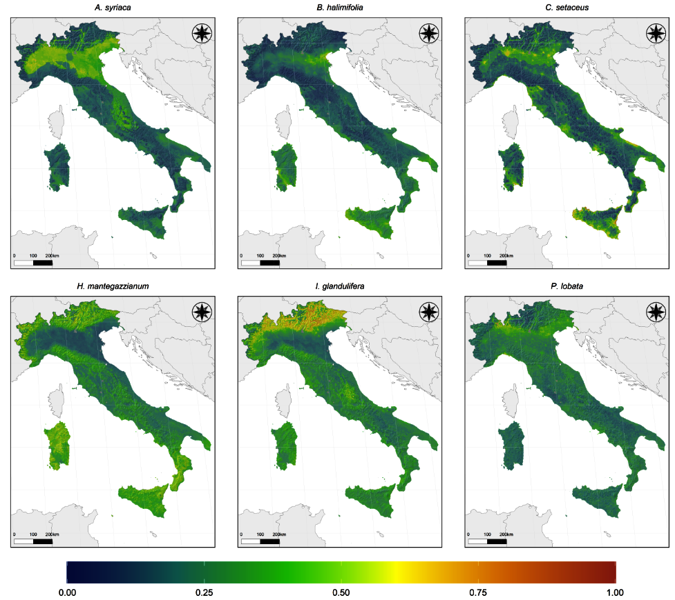

Figure S2. Invasion risk map across the three biogeographical regions of Italy: Alpine; Continental and Mediterranean, based on the ensemble modelling for eight aquatic invasive alien plants of Union concern in Italy: Alternanthera philoxeroides; Elodea nuttallii; Hydrocotyle ranunculoides; Lagarosiphon major; Ludwigia hexapetala; Ludwigia peploides; Myriophyllum aquaticum and Pontederia crassipes. The colours ranging from red (high invasion risk) to dark blue (low invasion risk) represent the risk of invasion (i.e., the average of the probability of occurrence for all species).

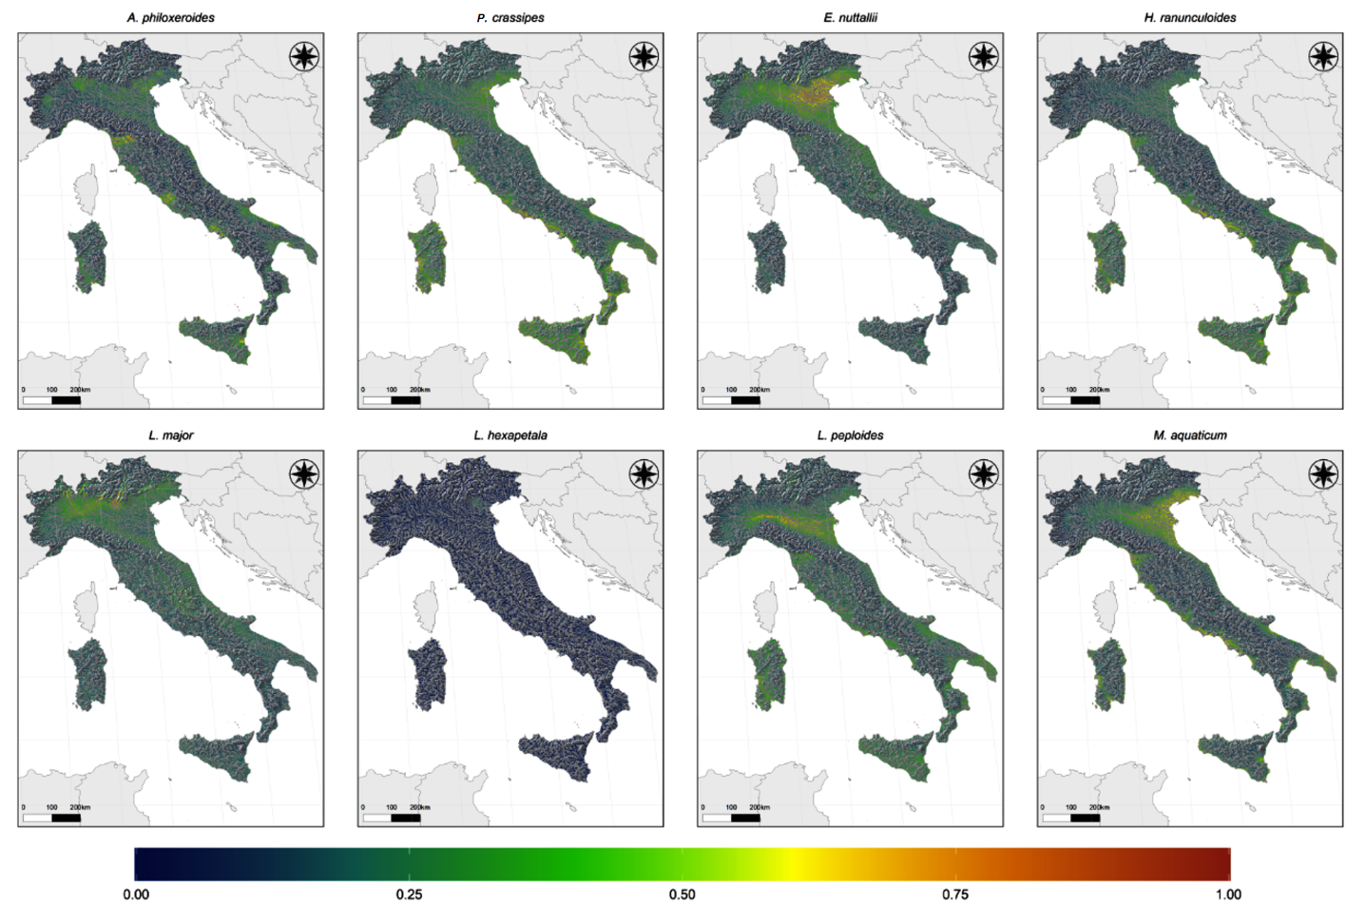

Figure S3. Histograms showing the results of the variable importance (%) evaluated in the ensemble forecast modelling for six terrestrial invasive alien plants of Union concern in Italy: Asclepias syriaca; Baccharis halimifolia; Cenchrus setaceus; Heracleum mantegazzianum; Impatiens glandulifera and Pueraria lobata (top). Response curves for the first four most important variables (colored in black in the histogram) (bottom).

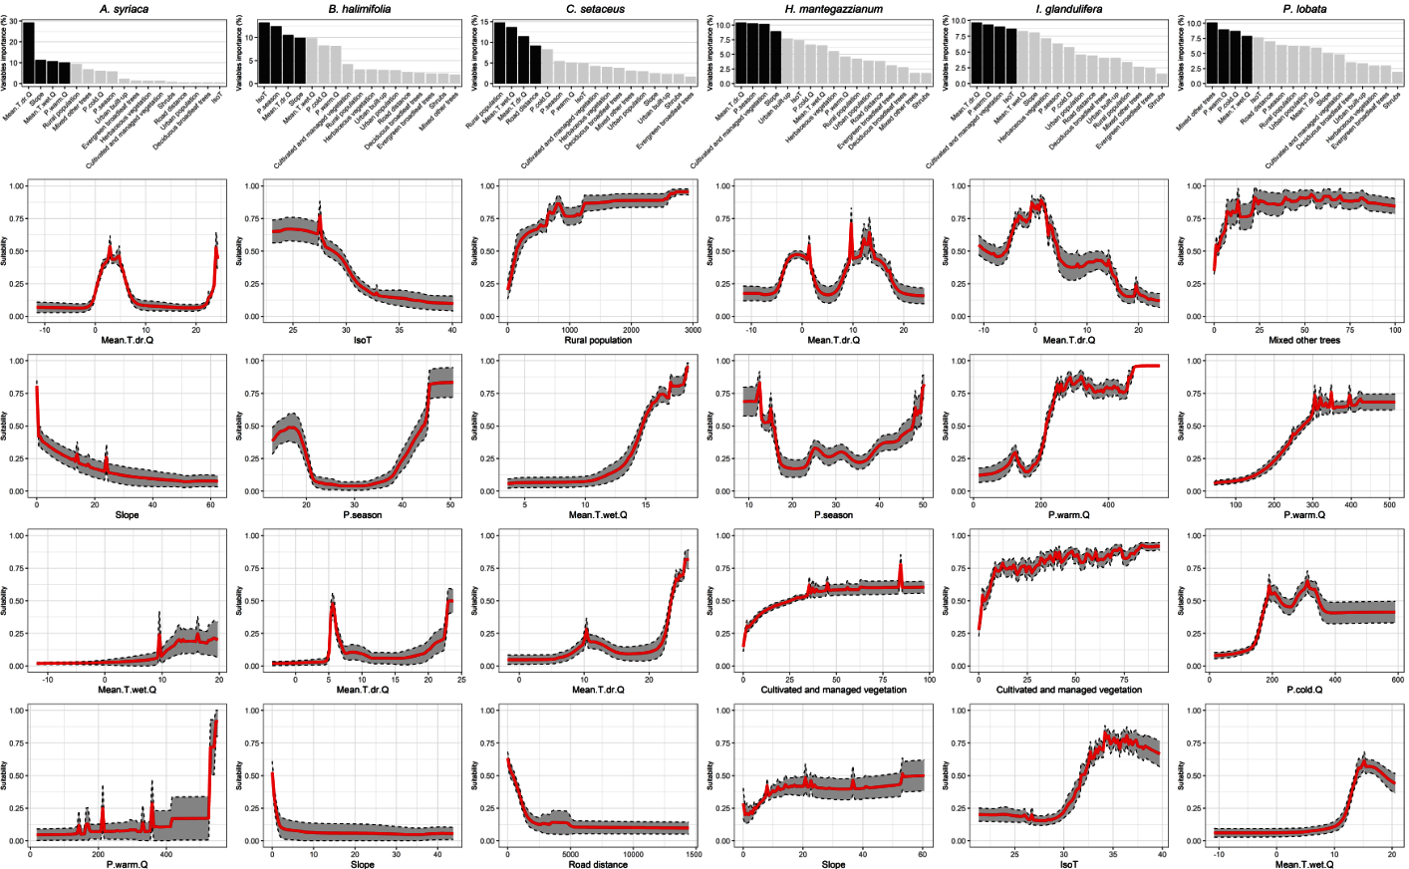

Figure S4. Histograms showing the results of the variable importance (%) evaluated in the ensemble forecast modelling for eight aquatic invasive alien plants of Union concern in Italy: Alternanthera philoxeroides; Elodea nuttallii; Hydrocotyle ranunculoides; Lagarosiphon major; Ludwigia hexapetala; Ludwigia peploides; Myriophyllum aquaticum and Pontederia crassipes (top). Response curves for the first four most important variables (colored in black in the histogram) (bottom).

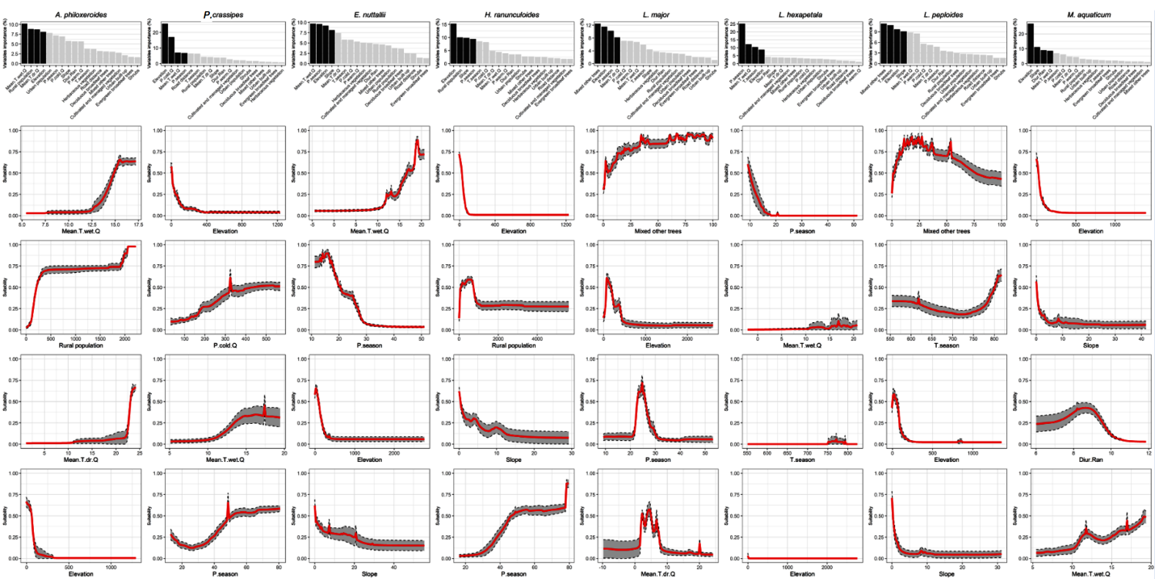

Figure S5. Multivariate Environmental Similarity Surface (MESS) analysis for six terrestrial invasive alien plants of Union concern in Italy: Asclepias syriaca; Baccharis halimifolia; Cenchrus setaceus; Heracleum mantegazzianum; Impatiens glandulifera and Pueraria lobata. Negative MESS values indicate areas of model extrapolation in which the value of at least one environmental predictor is beyond the environmental range covered by available presence-only records, so that predictions in those areas should be treated with strong caution. Increasingly non analogue climatic conditions (i.e., negative values < -20) are indicated in red.

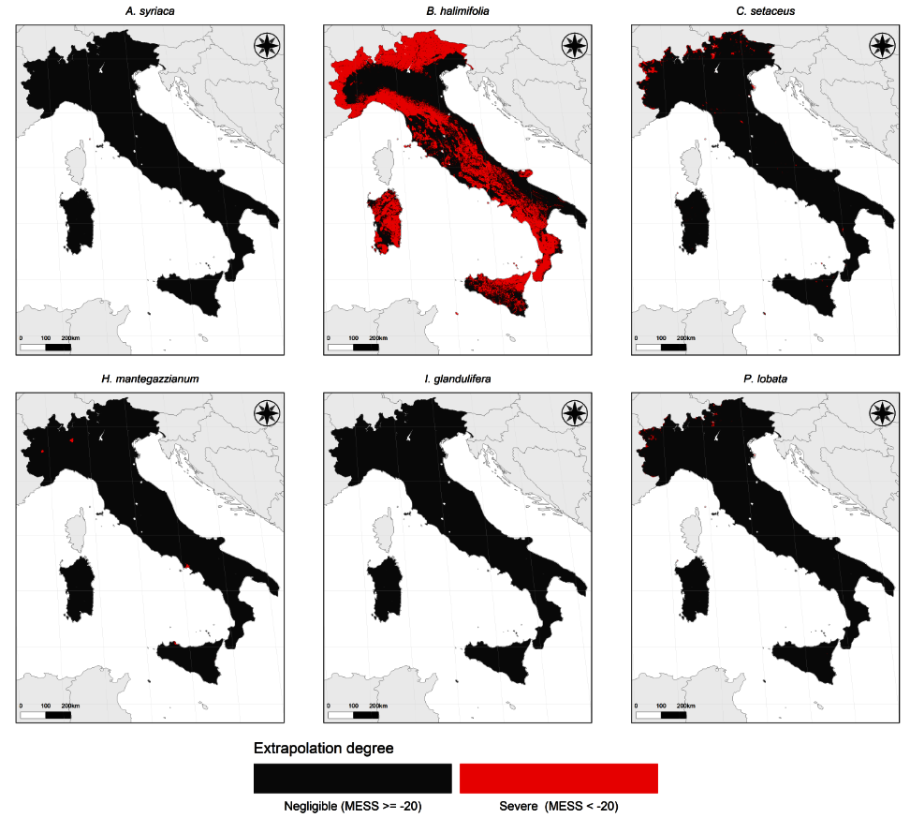

Figure S6. Multivariate Environmental Similarity Surface (MESS) analysis for eight aquatic invasive alien species of Union concern in Italy: Alternanthera philoxeroides; Elodea nuttallii; Hydrocotyle ranunculoides; Lagarosiphon major; Ludwigia hexapetala; Ludwigia peploides; Myriophyllum aquaticum and Pontederia crassipes. Negative MESS values indicate areas of model extrapolation in which the value of at least one environmental predictor is beyond the environmental range covered by available presence-only records, so that predictions in those areas should be treated with strong caution. Increasingly non analogue climatic conditions (i.e., negative values < -20) are indicated in red.
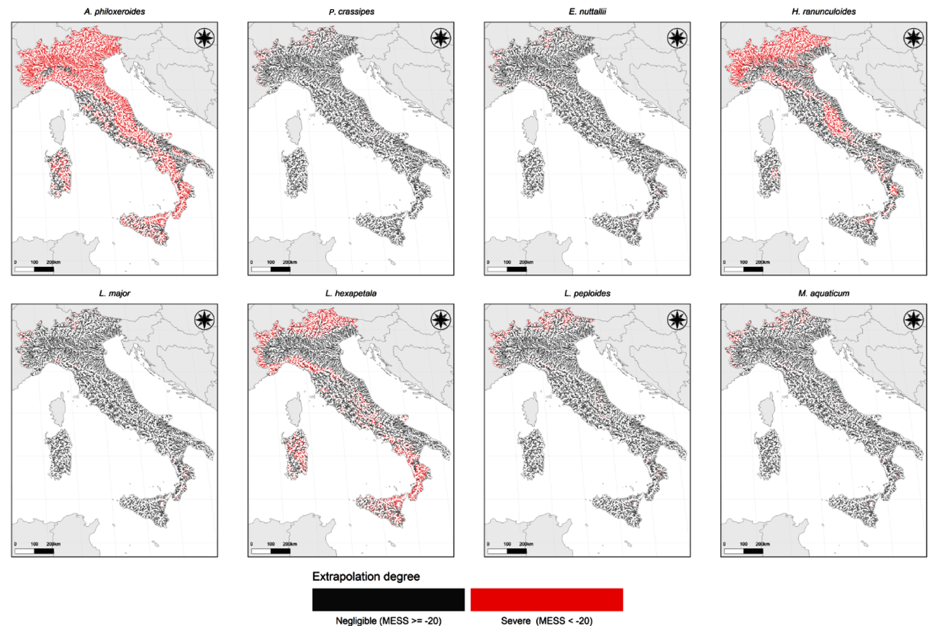

Figure S7. Local Interpretable Model-Agnostic Explanation (LIME) analysis, showing the propagule pressure, abiotic and biotic predictors related with aquatic invasive alien plants occurrence inside Natura 2000 protected area network across the different biogeographic regions (Mediterranean, Alpine, Continental). The analysis was performed only for terrestrial invasive alien plants presenting significant difference in suitability values between inside and outside the Natura 2000 protected areas network (p value <0.05, see Figure 2). Color intensity indicates variable importance from light blue (0: low) to dark blue (0.4: high). Absolute variable values are reported inside each cell. For variables description see table 1.

Figure S8. Local Interpretable Model-Agnostic Explanation (LIME) analysis, showing the propagule pressure, abiotic and biotic predictors related with aquatic invasive alien plants occurrence inside Natura 2000 protected area network across the different biogeographic regions (Mediterranean, Alpine, Continental). The analysis was performed only for aquatic invasive alien plants presenting significant difference in suitability values between inside and outside the Natura 2000 protected areas network (p value <0.05, see Figure 2). Color intensity indicates variable importance from light blue (0: low) to dark blue (0.3: high). Absolute variable values are reported inside each cell. For variables description see table 1.

